# YOUR NAME: HTML Summer 2021 Assignment #1

**Part 1: Your "Brackets and Live Preview" Screen shot**

[Paste your part 1 screen shot here. It should show both your Brackets window (with code showing) and your Live Preview window (with the heading showing) together in one screen shot. Resize or crop your image as needed for best grading purposes here in Word.]   
Paste your part 1 screen shot BELOW THIS LINE!]

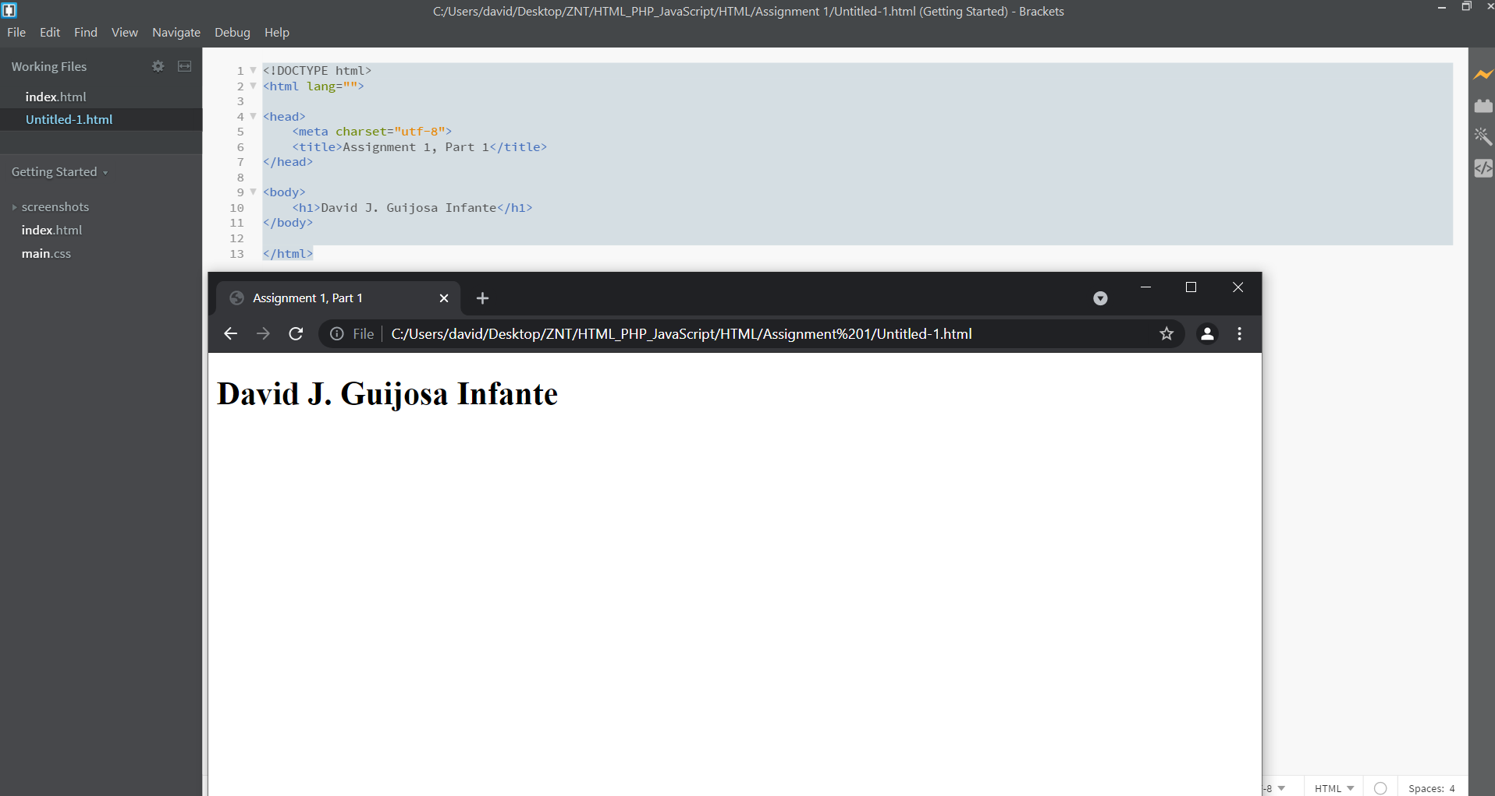

Paste your part 1 screen shot ABOVE THIS LINE!   
After pasting, then scroll down to the next page to paste your part 2 items.

**Part 2: Your "Resume" Screen shot(s)**

[Paste your part 2 screen shot(s) here. It should show your entire resume within the browser window (not in Brackets). No HTML code should be visible here – just your resume page in the browser. If you need more than 1 screen shot to capture the whole resume, that is fine. If it takes multiple pages in Word to contain them, that is fine too -- do not reduce the size of screen shots after pasting them into Word here just to fit them all on one page – the details of your screen shot must clearly visible in Canvas for grading purposes.]   
Paste your part 2 screen shot(s) BELOW THIS LINE!

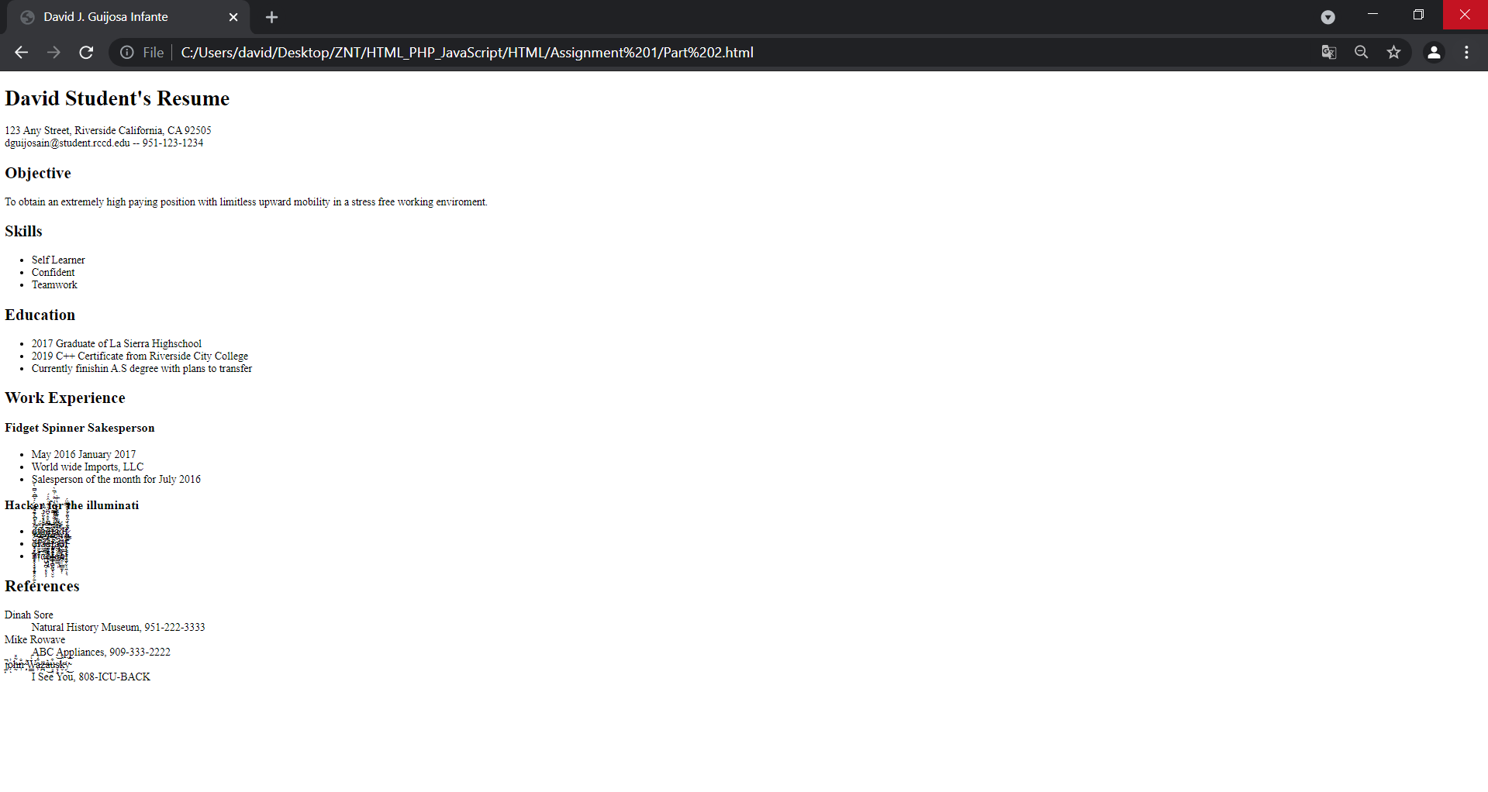

Paste your part 2 screen shot(s) ABOVE THIS LINE!   
After pasting, then scroll down to the next page to paste your part 2 code.

**Part 2: Your Resume Page Code**

[Paste your Resume Code below – Be sure to copy and paste ALL of the HTML code for the page (it is ok if it takes multiple pages here in Word. **Do NOT paste screen shots of your code** – paste the actual code from within Brackets (or other editor). After pasting, select the code and bold it here in Word. Then change the font to “Courier New” (or another monospace font) to make your code more readable. ]  
Paste your part 2 CODE BELOW THIS LINE!]

<!DOCTYPE html>

<html lang="">

<head>

<meta charset="utf-8">

<title>David J. Guijosa Infante</title>

</head>

<body>

<h1>David Student's Resume</h1>

<p>123 Any Street, Riverside California, CA 92505<br> dguijosain@student.rccd.edu -- 951-123-1234</p>

<h2>Objective</h2>

<p>To obtain an extremely high paying position with limitless upward mobility in a stress free working enviroment.</p>

<h2>Skills</h2>

<ul>

<li>Self Learner</li>

<li>Confident</li>

<li>Teamwork</li>

</ul>

<h2>Education</h2>

<ul>

<li>2017 Graduate of La Sierra Highschool</li>

<li>2019 C++ Certificate from Riverside City College</li>

<li>Currently finishin A.S degree with plans to transfer</li>

</ul>

<h2>Work Experience</h2>

<h3>Fidget Spinner Sakesperson</h3>

<ul>

<li>May 2016 January 2017</li>

<li>World wide Imports, LLC</li>

<li>Salesperson of the month for July 2016</li>

</ul>

<h3>Hacker for the illuminati</h3>

<ul>

<li>ḑ̷̧̨̡̨̛̹̺͔͙͉͓̮͕̫̜̝̭̖̩͙̞͓̭͕̱̙͐̈́͑̀͋͋̈̈́́̌̅͆̀̑͆̀̌͝f̸̢̧̛̘̝̤̬̹̀̈́à̴̡̨̨̧̬̮͖̩̣̹̳̟͎̱̺͓̪̖̣͓̞̗̇̐̎͛̾̈́̀̄̆̽͐̈́͛̃̏̀͘͠͠͝͠ͅḏ̶̨̢̞͈͉̤̰̠̭̻̟̩̭͉̘̠̿̃͆̊̑͒͆̈́͋̍̂̎́̕͠f̵̡̲̲̞̤͔͍̳̘̩͙̲͈͈̣̠̰̫͔̬̬̂̒͑̈̾̿̏́̉́̏͐̓̀̚̚͠͝ḁ̴̢̛̭̟̮̣̝̻̳̩̲̳̟͍̣͖͑͑͛̄̀̏́͌͗̈́̀͑̅͗͑͆̃̒̕͘͝d̵̻̦̦͍̫̖̲̟͍̳̪̭̜͇͚̙̜͒́f̷̧̢̧̨̪̩̱͕͎̤͎̜͉̱͍̫̞̬͔̼͉̈̀́̈̀̐̾̊̑̿̏̈́͜ͅ</li>

<li>ḑ̵͓̲̻͙̥̜̘̮̦̠͓̀̋͌̍̋́̽̋͆͑̑͛̕̚͘f̸̫̩̰̯͓͊͗̐͜͝a̶̛̫̫͔̠͋̉̀͂̓ͅd̶̠͙̳͔̗̱͉̒͌̃͠ͅf̴̡̨̨̜̙̱̭̲͇̦̪̙̤̂͗̆͐̒̈́̈́̂͌̚̚͝͝ͅa̸̡̭̣͔̤̖̤͚͋́̃̇̒͛̍͆̍̓͊̈́͘̕͘d̸͊́́͜f̵͙͕̄̀͛͗̊͒̀̈́̌̈́̈́͊̚͝</li>

<li>𝔡𝔣𝔞𝔡𝔣𝔞𝔡𝔣</li>

</ul>

<h2>References</h2>

<dl>

<dt>Dinah Sore</dt>

<dd>Natural History Museum, 951-222-3333</dd>

<dt>Mike Rowave</dt>

<dd>ABC Appliances, 909-333-2222</dd>

<dt>j̴̡͎̚o̷̗̓ͅh̶̰͂̽n̴̹̐ ̴̧͑W̵͇̒́a̵͕͒͗z̶̪̈a̶͛͜u̵͈͉͒s̸͙͔͝k̵̬̽͘y̴̯͜͝</dt>

<dd>I See You, 808-ICU-BACK</dd>

</dl>

</body>

</html>

Paste your part 2 CODE ABOVE THIS LINE!   
After pasting, save the page and exit Word. Then go to Canvas to submit it.